Cap’n MaGee

STM32H743 powered DSP board featuring 32 Mbyte SDRAM, 6-In & 8-Out 192kHz CODEC,   
a 24-bit RGB TFT interface, Hi-Speed USB and an SD card host interface.

Operating Conditions

* 5.0 V to 5.5 V, 0°C to +70°C w/ screen
* 4.75 V to 5.5 V, 0°C to +70°C w/o screen

Controller

**Core**

* 32-bit Arm® Cortex®-M7 core
* Double-precision FPU
* Up to 400 MHz

**Memories**

* 2 Mbytes of flash
* 32 Kbytes of L1 cache
* 192 Kbytes of TCM RAM
* 864 Kbytes of user SRAM
* 4 Kbytes of SRAM in Backup domain
* ECC on RAM and flash

**Clock management**

* Internal
  + 64 MHz HSI
  + 48 MHz HSI
  + 4 MHz CSI
  + 40 kHz LSI
* External
  + 16 MHz HSE
  + 32.768 kHz LSE

**Miscellaneous**

* 4 DMA controllers
* Up to 22 timers and watchdogs
* Chrom-ART Accelerator

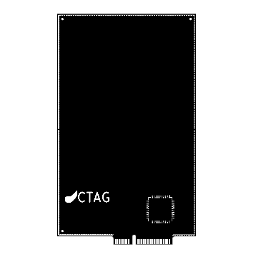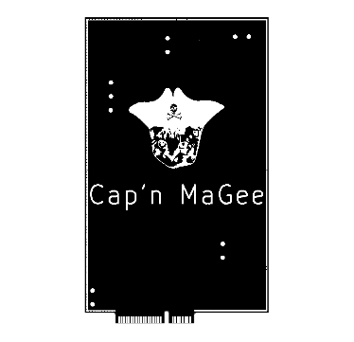

CODEC

**Features**

* 24-bit converters
* 192 kHz sampling frequency
* Digital volume control
* Time Division Multiplexed interface
* ADC Overflow Interrupt

**ADCs (Differential specs)**

* 105 dB Dynamic range
* -98 dB THD+N

**DACs (Differential specs)**

* 108 dB Dynamic range
* -98 dB THD+N

SDRAM

**Features**

* 100 MHz clock rate
* 4 banks of 8M word x 8 bit
* Auto Refresh
* Programmable burst modes
* Power down mode

Connector

* Mini PCI-e Fingers

# Pinout

## Front

## C:\Users\Jesse\AppData\Local\Microsoft\Windows\INetCache\Content.Word\Outline Front Connector.png

|  |  |  |
| --- | --- | --- |
| 1 | Vbus | USB Power Output |
| 3 | Vaux | Auxiliary Power Input |
| 5 | I2C4_SDA/GPIO | Open Drain/Push-Pull/Input |
| 7 | USART6_TX/GPIO | Open Drain/Push-Pull/Input |
| 9 | SPI2_MOSI/GPIO | Open Drain/Push-Pull/Input |
| 11 | SPI2_MISO/GPIO | Open Drain/Push-Pull/Input |
| 13 | HRTIM_EEV3 | Open Drain/Push-Pull/Input |
| 15 | HRTIM_FLT3 | Open Drain/Push-Pull/Input |

|  |  |  |
| --- | --- | --- |
| 17 | SPDIFRX_IN1 | Open Drain/Push-Pull/Input |
| 19 | COMP_1_INP | Open Drain/Push-Pull/Input/Analog In |
| 21 | ADC3_INP6 | Open Drain/Push-Pull/Input/Analog In |
| 23 | ADC1_INP16 | Open Drain/Push-Pull/Input/Analog In |
| 25 | AOUT1+ | Analog Output + |
| 27 | AOUT2+ | Analog Output + |
| 29 | AOUT3+ | Analog Output + |
| 31 | AOUT4+ | Analog Output + |
| 33 | AOUT5+ | Analog Output + |
| 35 | AOUT6+ | Analog Output + |
| 37 | AOUT7+ | Analog Output + |
| 39 | AOUT8+ | Analog Output + |
| 41 | AIN1+ | Analog Input + |
| 43 | AIN2+ | Analog Input + |
| 45 | AIN3+ | Analog Input + |
| 47 | AIN4+ | Analog Input + |
| 49 | AIN5+ | Analog Input + |
| 51 | AIN6+ | Analog Input + |

## Back

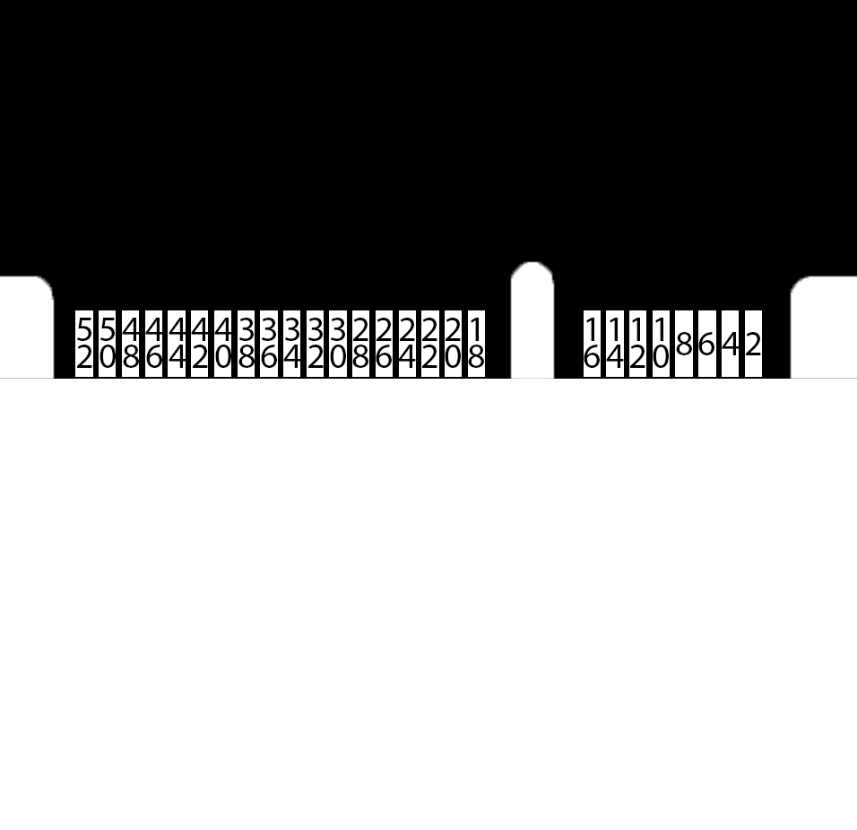

|  |  |  |
| --- | --- | --- |
| 2 | GND | Ground |
| 4 | Vbat | Battery Power Input |
| 6 | I2C4_SCL/GPIO | Open Drain/Push-Pull/Input |
| 8 | USART6_RX/GPIO | Open Drain/Push-Pull/Input |
| 10 | SPI2_NSS/GPIO | Open Drain/Push-Pull/Input |
| 12 | SPI2_SCK/GPIO | Open Drain/Push-Pull/Input |
| 14 | HRTIM_CHE1/GPIO | Open Drain/Push-Pull/Input |
| 16 | MCO1/GPIO | Open Drain/Push-Pull/Input |

|  |  |  |
| --- | --- | --- |
| 18 | DAC1_OUT1/GPIO | Open Drain/Push-Pull/Input/Analog Out |
| 20 | COMP1_OUT/GPIO | Open Drain/Push-Pull/Input |
| 22 | ADC123_INP11/GPIO | Open Drain/Push-Pull/Input/Analog In |
| 24 | ADC12_INP3/GPIO | Open Drain/Push-Pull/Input/Analog In |
| 26 | AOUT1- | Analog Output - |
| 28 | AOUT2- | Analog Output - |
| 30 | AOUT3- | Analog Output - |
| 32 | AOUT4- | Analog Output - |
| 34 | AOUT5- | Analog Output - |
| 36 | AOUT6- | Analog Output - |
| 38 | AOUT7- | Analog Output - |
| 40 | AOUT8- | Analog Output - |
| 42 | AIN1- | Analog Input - |
| 44 | AIN2- | Analog Input - |
| 46 | AIN3- | Analog Input - |
| 48 | AIN4- | Analog Input - |
| 50 | AIN5- | Analog Input - |
| 52 | AIN6- | Analog Input - |

## Test points

1.5mm test points are located at the back. Shown here is the front of the PCB.

|  |  |  |  |
| --- | --- | --- | --- |
| **No.** | **Description** | **X (mm)** | **Y (mm)** |
| 1 | D+ | 6.45 | 93.75 |
| 2 | D- | 10.95 | 93.75 |
| 3 | TFT_LED- | 33.00 | 93.25 |
| 4 | TFT_LED+ | 33.00 | 88.75 |
| 5 | PROG_CLK | 51.50 | 78.75 |
| 6 | PROG_IO | 51.50 | 74.25 |
| 7 | NRST | 51.50 | 69.75 |
| 8 | +3V3 | 15.00 | 26.00 |
| 9 | +5V | 15.00 | 21.50 |
| 10 | +3V3_LDO | 57.50 | 10.75 |
| 11 | GND | 57.50 | 6.25 |
| M | M3 mounting | 33.30 | 80.20 |

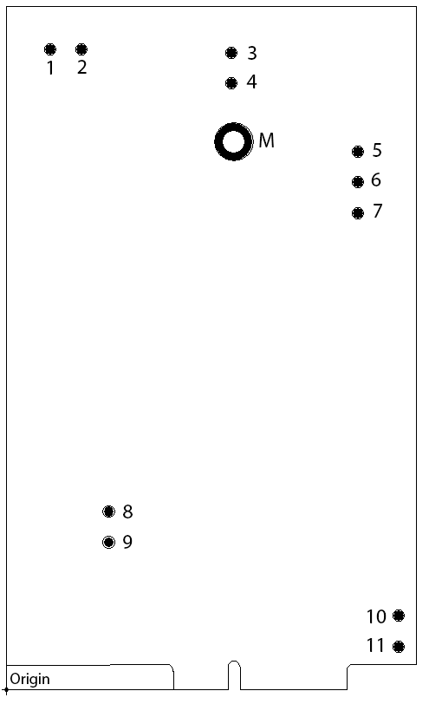

## Connectors

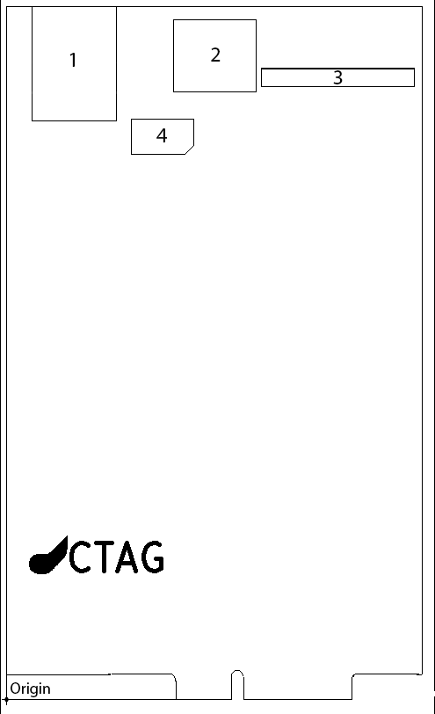

|  |  |  |  |  |  |  |
| --- | --- | --- | --- | --- | --- | --- |
| **No.** | **Description** | **X1 (mm)** | **Y1 (mm)** | **X2 (mm)** | **Y2 (mm)** | **Type** |
| 1 | USB type B | 3.60 | 83.50 | 15.80 | 100.00 | User |
| 2 | SD Card | 24.05 | 86.50 | 36.00 | 98.20 | User |
| 3 | Display | 36.80 | 88.35 | 58.90 | 91.05 | System |
| 4 | Touch | 17.95 | 78.75 | 26.95 | 83.75 | System |

# Dimensions

|  |  |  |
| --- | --- | --- |
| **No.** | **X (mm)** | **Y (mm)** |
| 1 | 24.25 | 3.55 |
| 2 | 32.60 | 4.00 |
| 3 | 34.00 | 4.00 |
| 4 | 50.00 | 3.55 |
| 5 | 60.00 | 100.00 |

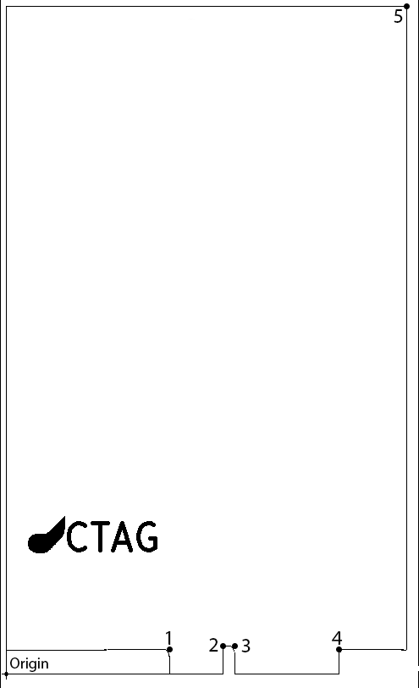

# Programming

The programming header is located on the front of the board below the right top corner. Its pinout from top to bottom is as follows: +3V3, CLK, GND, IO, NRST and SWO.

Below the header is a button to reset the microcontroller.

# Electrical Characteristics

## Absolute maximum ratings

|  |  |  |  |
| --- | --- | --- | --- |
| **Ratings** | **Min** | **Max** | **Unit** |
| Operating temperature range | 0 | +70 | °C |
| Voltage on power inputs in respect to GND w/ display | 5.0 | 5.5 | V |
| Voltage on power inputs in respect to GND w/o display | 4.75 | 5.5 | V |
| Voltage on digital inputs (except for pin 18 & 20) | -0.3 | 5.5 | V |
| Voltage on analog inputs | -0.3 | 3.6 | V |
| Current into power pins |  | 1.25 | A |
| Current sunk or sourced by all GPIO pins |  | 20 | mA |
| Total current sunk or sourced by all GPIO pins |  | 140 | mA |
| Injected current on MCU pins |  | -5 | mA |
| Total injected current |  | ±25 | mA |

## Typical characteristics

|  |  |  |
| --- | --- | --- |
| **Ratings** | **Typ.** | **Unit** |
| Standby current | 60 | mA |
| CODEC current | 190 | mA |
| RAM write current | 15 | mA |
| RAM read current | 75 | mA |
| LCD current | 70 | mA |
| Backlight current | 340 | mA |
| Backlight driver efficiency | 58.8 | % |
| USB current |  | mA |

# Key Components

|  |  |
| --- | --- |
| Microcontroller | STM32H743IIT6 |
| SDRAM | AC4C32M8SA-7TCN |
| CODEC | CS42448-CQZ |
| Power Multiplexer | TPS2113ADRBR |
| Supply Digital rail +3V3 | MIC23050-SYML-TR |
| Supply Analog rail +3V3 | ADP150AUJZ-3.3-R7 or ADP151AUJ Z-3.3-R7 |
| Supply Backlight | TPS61170DRVR |
| USB Phy | USB3300-EZK |

A screen compatible with this board is the Newhaven Display NHD-5.0-800480TF-ATXL#-CTP.